**9.6 Exercises**

**Defining Terms**

**1. Class**

Classes are basically similar to blueprints and templates that define their characteristics. They are entirely separate from objects.

**2. Objects**

Objects are entities that have a unique ability and characteristics. They are usually based from classes

**3. Instantiate**

"Instantiate" means creating an new object from a class. Like two identical buildings, each has a different design but the materials used to build are the same.

**4. Instance Variables**

Instance Variables are the characteristics of an object coming from a class.

**5. Instance Methods**

Instance Methods are methods that are instantiated from a class to an object.

**6. Class Variables or static member variables**

Class Variables are variables that belong to a class, and can be modified by an object when instantiating it.

**7. Constructors**

A constructor is a special method used in declaring initial values for objects and their attributes.

**Java Scavenger Hunt**

1. Look for a method that checks if a certain String ends with a certain suffix. For example, if the given string is "Hello", the method should return true the suffix given is "lo", and false if the given suffix is "alp".

Method:

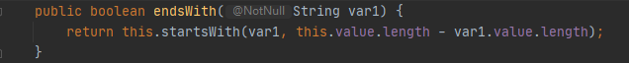

Output:

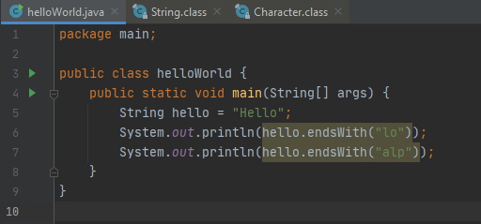

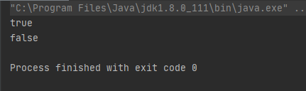

1. Look for the method that determines the character representation for a specific digit in the specified radix. For example, if the input digit is 15, and the radix is 16, the method would return the character F, since F is the hexadecimal representation for the number 15 (base 10).

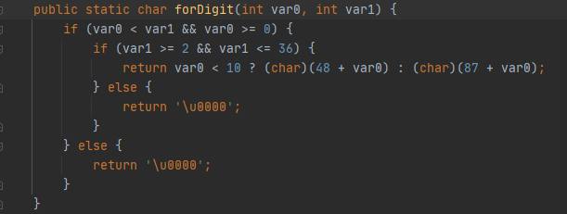

1. Look for the method that terminates the currently running Java Virtual Machine

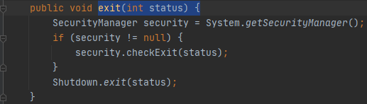

1. Look for the method that gets the floor of a double value. For example, if I input a 3.13, the method should return the value 3.

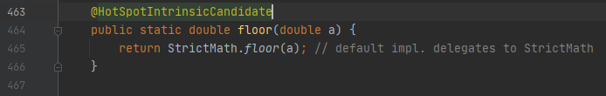

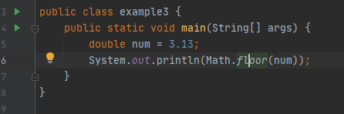

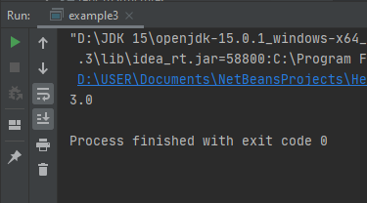

1. Look for the method that determines if a certain character is a digit. For example, if I input '3', it returns the value true.

